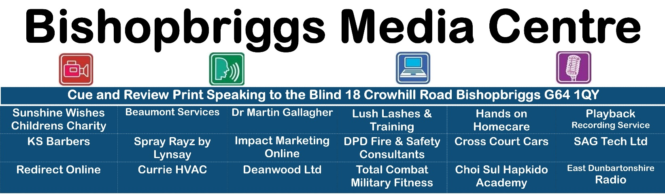
Application for Bishopbriggs Media Centre Administrator
Please return the completed form to:
Company Secretary
Cue and Review Recording Service, Bishopbriggs Media Centre,
18 Crowhill Road, Bishopbriggs, Glasgow G64 1QY
alastairmcphee@cueandreview.com
0141-772-3976 (email preferred)

1. Details of the applicant
It is important that the Company Secretary is able to contact you if more information is required. Please give as much detail as possible.
Mr Ms Mrs Dr Other:
Given name/s |  |  |  |  |  |  |  |  |  | Surname
Occupation |  |  |  |  |  |  |  |  |  | Date of Birth
Postal address
Town |  |  |  |  |  | City |  |  |  |  |  | Postcode
Daytime telephone |  |  |  |  |  |  |  |  | Mobile
Email address
Do you have special needs for assistance with this application? |  |  |  |  |  |  |  |  | Yes No (Tick one)
If yes, please specify:

2 Detail your knowledge of Office 365 and Microsoft Teams, include any information on using these remotely and in a lone setting.

3. What previous relevant experience do you have when dealing with Councils and utility companies and of maximising the use of limited resources.

4. What skills/attributes do you have that would be relevant to the post
5. Privacy and personal information protection notice
•this information is voluntarily required to process your request and will not be used for any other purpose without seeking your consent, or as required by law;
•your personal information can be accessed and corrected at any time by contacting the Company Secretary.

Applicant’s Signature/s
I declare that to the best of my knowledge all particulars supplied by me are correct and completed. I understand that inaccurate or false statements may cause my application to be delayed or rescinded.
Signature: ……… Date: …
Office Use Only
Date received

